GYM WEBSITE ( FITNESS HUB )

PROJECT – I REPORT

Submited by

RAHUL SHARMA 2021-310-179
in partial fulfillment for the award of the degree of
B.TECH COMPUTER SCIENCE & ENGINEERING

Under the supervision of

DR. AAINA


Department of Computer Science& Engineering School of Engineering Sciences & Technology JAMIA HAMDARD
New Delhi-110062

2024

DECLARATION

I, RAHUL SHARMA a student of B-TECH CSE 6th Semester, Enrolment No:2021-310-179 hereby declare that the Project/Dissertation entitled “ GYM WEBSITE ” which is being submitted by me to the Department of Computer Science, Jamia Hamdard, New Delhi in partial fulfillment of the requirement for the award of the degree of B-TECH CSE is my original work and has not been submitted anywhere else for the award of any Degree, Diploma, Associateship, Fellowship or other similar title or recognition.

(Signature and Name of the Applicant)

Date : 25th March 2024
Place : JAMIA HAMDARD

ACKNOWLEDGEMENT
I would like to express my special thanks of gratitude to my teacher DR. AAINA , my friends Qamber Raza and Aftab Alam who gave me the golden opportunity to do this wonderful project on the topic GYM WEBSITE, which also helped me in doing a lot of Research and I came to know about so many new things I am really thankful to them.

DATE :

Rahul Sharma
B.TECH (CSE) 6TH SEMESTER
Department Of Computer Science & Engineering
JAMIA HAMDARD , New Delhi
LIST OF ABBREVIATIONS
- RAM - Random Access Memory
- Gym - Gymnasium
- HTML - Hypertext Markup Language
- CSS - Cascading Style Sheets
- IOS - iPhone Operating System (iOS)
- GPU - Graphics Processing Unit
- SSD - Solid State Drive
- Tech - Technology
- Data – Data
- OS - Operating System
- GB - Gigabyte
- CPU - Central Processing Unit
- UI - User Interface
- UX - User Experience
- API - Application Programming Interface
- QA - Quality Assurance

SR. NO. | Chapter Name | Page No
01 | Abstract | 5
02 | Introduction | 6
03 | Problem statement | 7
04 | User Function specification | 8
05 | Hardware Requirement | 9
06 | Technology Used In Project | 10
07 | Data Flow Diagram (DFD) | 11-12
08 | User Case Diagram | 13
09 | Snapshots | 14-16
10 | Conclusion | 17
11 | BIBLIOGRAPHY AND REFRENCES | 18
CONTENT

ABSTRACT

The Gym Website Project (Fitness Hub) aims to revolutionize the way gym members interact with their fitness facilities by providing an intuitive online platform for class booking, progress tracking, and communication with trainers. In response to the growing demand for digital fitness solutions, our website leverages modern web technologies to create a seamless user experience that promotes engagement and enhances the overall gym experience. In today's fast-paced world, the importance of fitness and well-being has never been more evident. With an increasing number of individuals turning to gyms and fitness centers to maintain a healthy lifestyle, the demand for modern, convenient, and user-friendly gym management solutions is at an all-time high. Traditional gym management systems often fall short in meeting the evolving needs of both gym owners and members, relying on manual processes, outdated technology, and paper-based systems that are prone to errors, inefficiencies, and limited accessibility. At its core, Fitness Hub aims to provide gym owners with a powerful yet easy-to-use tool for managing their facilities more efficiently.

INTRODUCTION
In recent years, the fitness industry has witnessed a shift towards digital solutions to meet the evolving needs of gym-goers. Our project seeks to address this trend by developing a comprehensive gym website that caters to the diverse needs of members and trainers alike. By providing features such as class booking, progress tracking, and communication tools, our website aims to streamline gym management processes and enhance the overall user experience.
OBJECTIVES :
The primary objectives of our gym website project include :
- Providing an online platform for gym members to book classes, track their progress, and communicate with trainers.
- Empowering trainers with tools to manage class schedules, track client progress, and provide personalized guidance.
- Creating a seamless and user-friendly experience that encourages engagement and retention among gym members.
SCOPE :
The scope of our project encompasses the development of a fully functional gym website with the following features :
- User registration and authentication system to ensure secure access to member accounts.
- Class booking and scheduling functionalities, allowing members to reserve slots in their preferred classes.
- Progress tracking tools for members to monitor their fitness goals and achievements.
- Communication features that enable members to interact with trainers and receive personalized guidance and support.
PROBLEM STATEMENT

Traditional gym management systems rely heavily on manual processes and outdated technology, resulting in inefficiencies and limitations for both gym owners and members. Manual class booking systems often lead to overbooking or scheduling conflicts, while paper-based progress tracking makes it challenging for members to monitor their fitness goals effectively. Additionally, the lack of a digital communication platform between members and trainers hinders personalized support and guidance.

In light of these challenges, there is a clear need for a modern and comprehensive gym management solution that streamlines operations, enhances user experience, and fosters better communication between gym owners, trainers, and members. Our project seeks to address these pain points by developing a user-friendly gym website that offers seamless class booking, progress tracking, and communication features, ultimately revolutionizing the way fitness facilities are managed and experienced.

USER FUNCTION SPECIFICATION

User Registration
The user registration process allows individuals to create an account with their email and password. Upon registration, users are assigned a unique member ID, which they can use to access the various features of the gym website.
Class Booking
Members can browse the available classes and book slots in their preferred sessions. Trainers have the ability to create and manage class schedules, including setting capacities and updating availability.
Communication
Members can communicate with trainers through messaging features built into the website. Trainers can send notifications and updates to members about upcoming classes, changes to schedules, or personalized training advice.

HARDWARE REQUIREMENT
The gym website can be accessed using standard hardware, including desktop or laptop computers, smartphones, or tablets with internet connectivity. There are no specific hardware requirements beyond a reliable internet connection and a compatible web browser.
For Users:
Desktop or Laptop Computer:
Operating System: Windows, macOS, Linux
Processor: Intel Core i3 or equivalent
Memory (RAM): 4GB or higher
Graphics: Integrated or dedicated GPU with support for modern web browsers
Storage: 128GB or higher

Smartphone or Tablet:
Operating System: iOS, Android
Processor: Snapdragon 600 series or equivalent (for Android), Apple A10 Fusion or equivalent (for iOS)
Memory (RAM): 2GB or higher
Display: Minimum resolution of 720p

For Gym Owners/Managers:
Desktop or Laptop Computer:
Operating System: Windows, macOS, Linux
Processor: Intel Core i5 or equivalent
Memory (RAM): 8GB or higher
Storage: 256GB SSD or higher

TECHNOLOGY USED IN PROJECT

Languages used in website :
• HTML: Provides the structure and content for a website, defining elements like headings, paragraphs, images, and links that browsers interpret and display to users.
• CSS (Cascading Style Sheets): It controls the presentation and layout of a website, allowing developers to style elements like text, colors, fonts, and layout to create visually appealing and cohesive designs.
• JAVA SCRIPT: It adds interactivity and dynamic functionality to websites, allowing developers to create features like form validation, animations, and interactive elements that respond to user actions

- Web hosting server : GITHUB ( Render )

DATA FLOW DIAGRAM

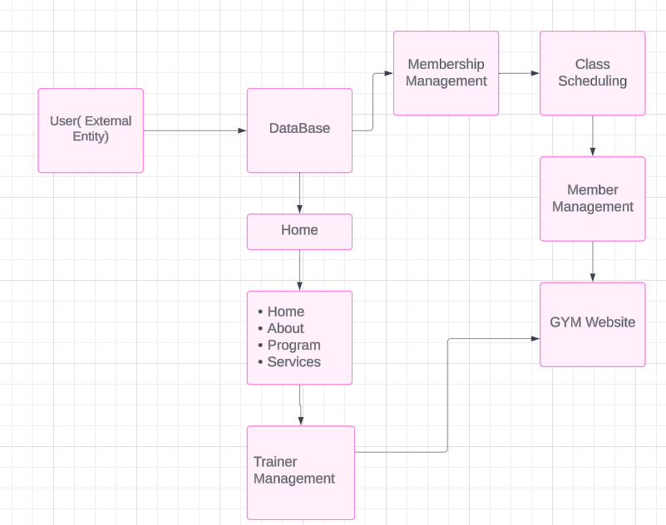

Data Flow:
Member/Trainer Data: Flow of data between the Member and Trainer Management processes and the Database, representing user registration, login, and profile information.
Class Data: Flow of data between the Class Scheduling process and the Database, representing class schedules, bookings, and updates.
Membership Data: Flow of data between the Membership Management process and the Database, representing membership plans, payments, and renewals.
Website Content Data: Flow of data between the Home, About, Program, and Services processes and the Database, representing the content displayed on these pages.
User Interaction Data: Flow of data between the various sections of the website and the user, representing user interactions such as clicking on the "Join Now" button, booking classes, and selecting membership plans.

USER CASE DIAGRAM

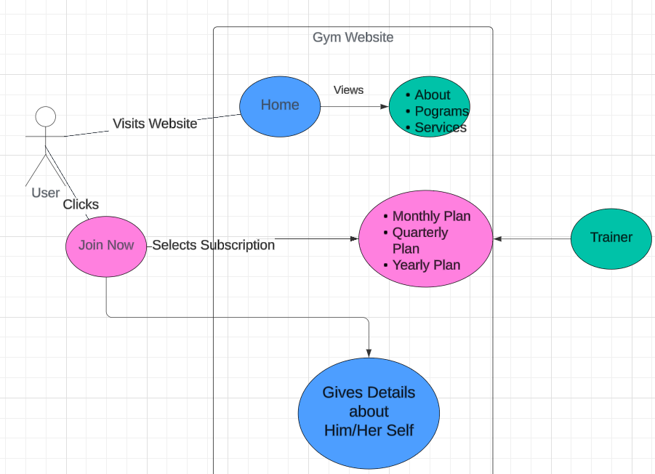

SNAPSHOTS
HOME PAGE :
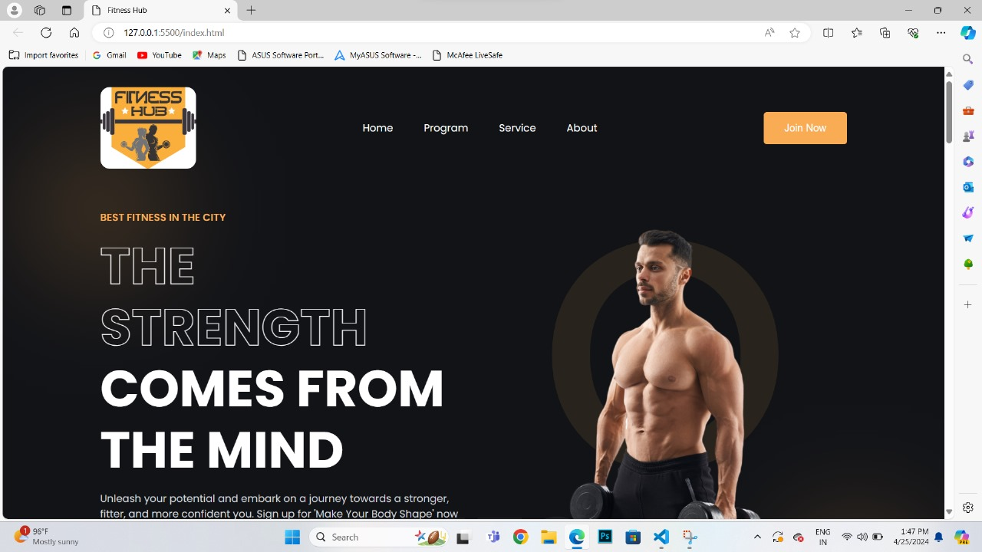
PROGRAMS :
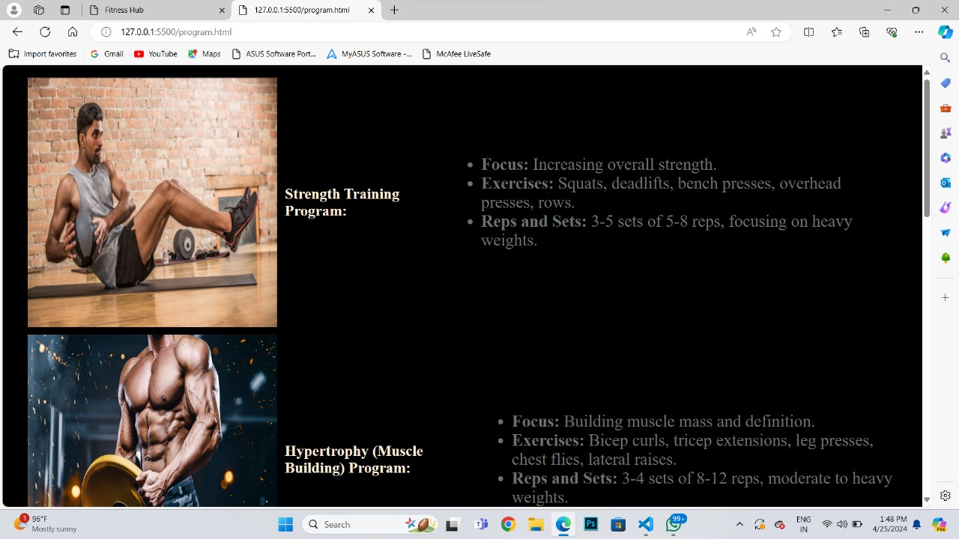
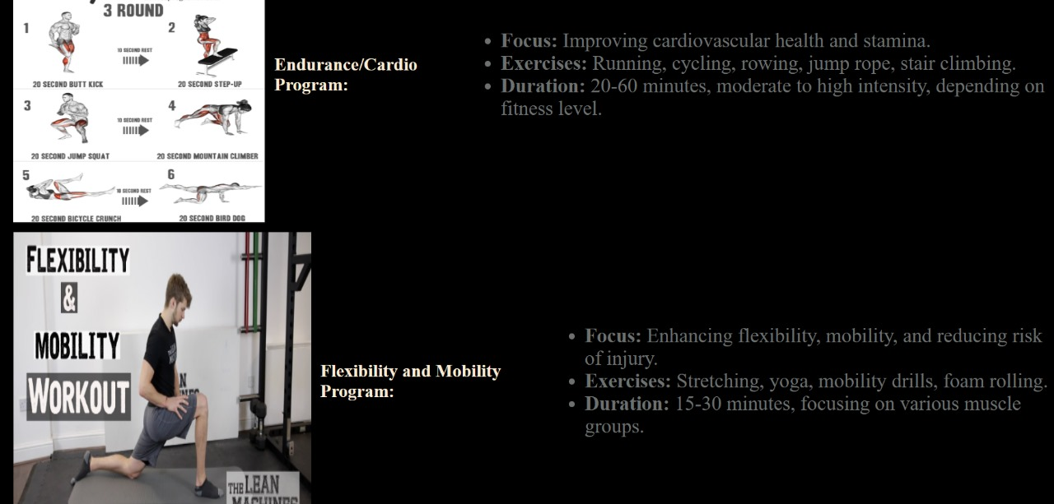
SERVICES :
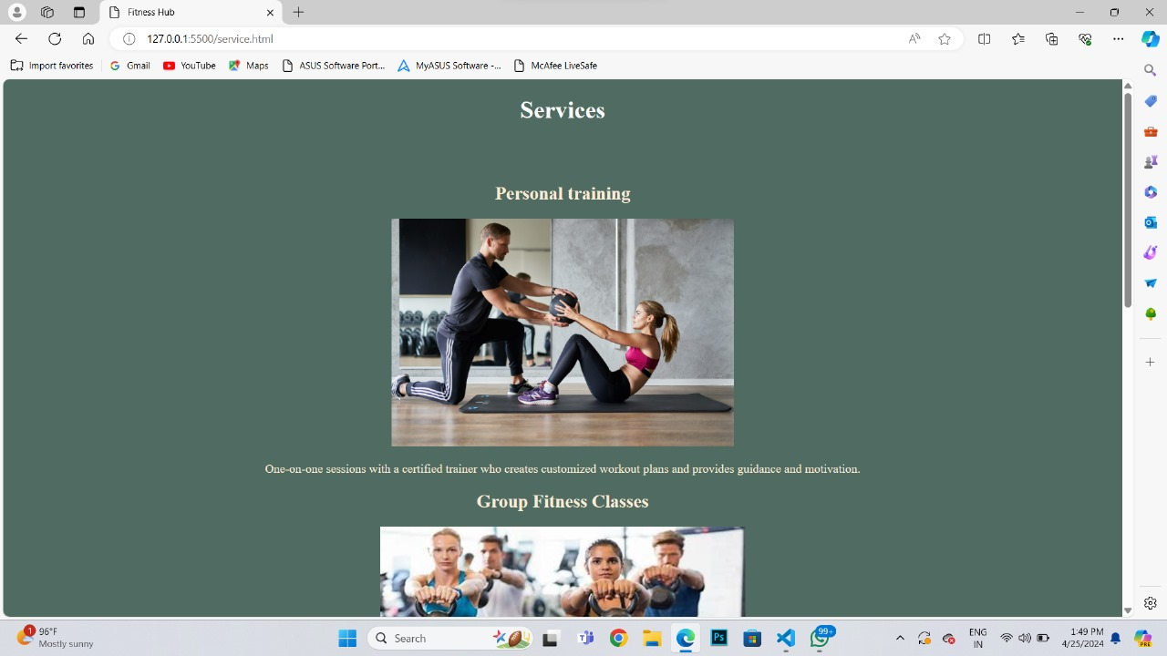
ABOUT SECTION :
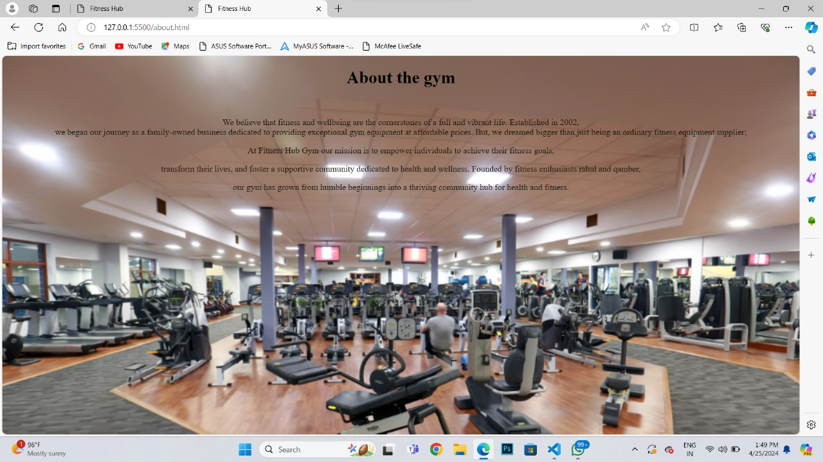
JOIN NOW :
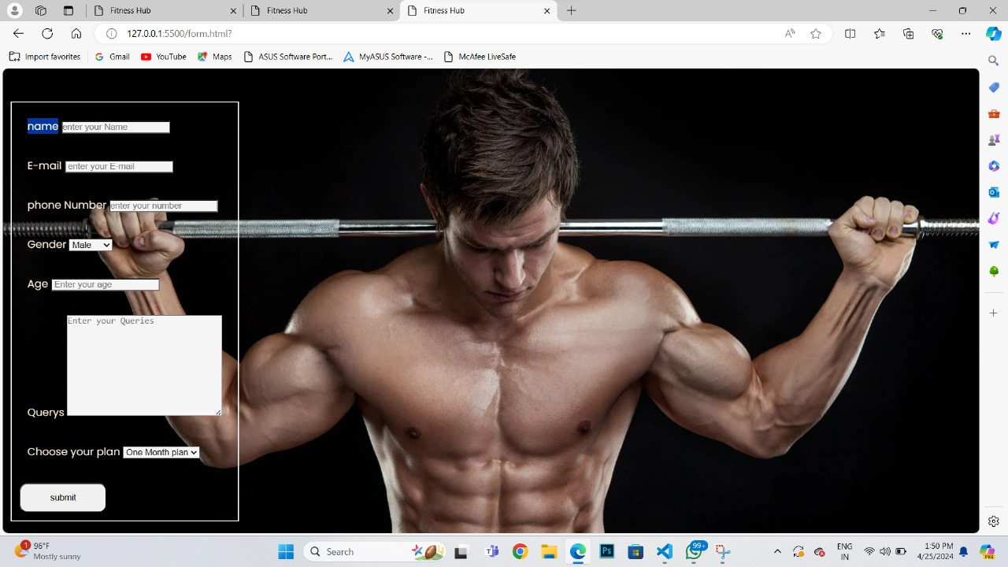
CONCLUSION

The development of the gym website has been a significant endeavor aimed at enhancing the fitness experience for both users and gym administrators. Through this project, we have successfully addressed several challenges faced by gym-goers and streamlined the management processes for the gym staff.
Achievements :
- We have created a user-friendly interface that provides easy access to information about gym facilities, programs, and services.
- The subscription management system implemented on the website has simplified the process for users to select and manage their subscription plans.
- The integration of a program management system allows trainers to create personalized fitness programs and track user progress effectively.
Lessons Learned :
Throughout the project, we have gained valuable insights into various aspects of web development, including frontend and backend technologies, user experience design, and project management. Some key lessons learned include:
- The importance of thorough planning and requirement analysis before starting development.
- The significance of continuous testing and quality assurance to ensure a smooth user experience.
- The value of user feedback in iterating and improving the website over time.
In conclusion, the gym website development project has been a rewarding experience, and we believe that the website will continue to evolve and improve to meet the changing needs of our users and the fitness industry as a whole.

BIBLIOGRAPHY AND REFRENCES

- Fitness industry trends: Various industry reports from sources like IHRSA (International Health, Racquet & Sportsclub Association) or Statista. https://www.statista.com/ https://www.ideafit.com/personal-training/the-essential-role-of-fitness-and-physical-activity-hope-for-the-future/

- Articles from fitness magazines or websites: Websites such as Men's Health, Women's Health, Healthline, etc.
https://apo.org.au/node/76278
https://books.google.com/books?hl=en&lr=&id=3aZ2n73UsTAC&oi=fnd&pg=PA5&dq=Articles+from+fitness+magazines+or+websites:+Websites+such+as+Men%27s+Health,+Women%27s+Health,+Healthline,+etc.&ots=p8_7NmhUPj&sig=9bc2EW2LCoRVOqhQ2tCVfr4JvNM
https://conservancy.umn.edu/handle/11299/172267
- Industry reports on fitness industry trends and challenges.
http://journals.uran.ua/sport_herald/article/view/104259
https://journals.lww.com/acsm-healthfitness/fulltext/2024/01000/2024_acsm_worldwide_fitness_trends__future.7.aspx

- https://www.health.harvard.edu/
- https://www.everydayhealth.com/
- https://books.google.com/books?hl=en&lr=&id=_134DwAAQBAJ&oi=fnd&pg=PP1&dq=gym+fitness+books+articles&ots=4IF9kRsMHS&sig=RwMzrCgyGbub2nJbijcCralDNKg
- The Fitness Movement and the Fitness Center Industry, 1960-2000 https://thebhc.org/sites/default/files/stern_0.pdf
- The Fitness Revolution: Historical Transformations in the Global Gym and Fitness Culture.
- https://www.tandfonline.com/doi/pdf/10.1080/23267402.1936.10761782

